Solve the SQL fundamentals Query:

1. Display the name of movies, movie type is starts with Drama.

ANS: select moviename from movie where Movietype like "Drama%";

1. Display the movies acted by actor Ayushmann.

Ans: select Moviename from movie where Heroname like "Ayushmann";

1. Display the count of movies, having length above 18.

Ans:select count(Moviename) from movie where Length>18;

1. Display the movie having minimum length.

Ans: select Moviename from movie where Length=(select min(Length) from movie);

1. Display all the details of movie, the language that first name starts with ‘T’

Ans: select \*from movie where Language like 'T%';

1. Display the movie name, hero name, heroine name whose having maximum length.

Ans:select Moviename,Heroname,Heroine from movie where Length=(select max(Length)from movie);

7.Display the movie name, hero name, heroine name the movie released after 15 march 2018.

Ans:select Moviename,Heroname,Heroine from movie where Releaseddate>'2018-03-15';

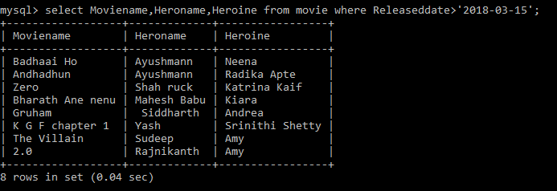

8.Display the count of thriller movies.

Ans:select count(Moviename) from movie where movietype like '%Thriller';

9.Display the count of movies whose released before 15 march 2018.

Ans: select count(Moviename) from movie where Releaseddate<'2018-03-15';

1. Display the release date of the movie name ‘Zero’.

Ans:select Releaseddate from movie where Moviename='Zero';

11.Display the actor name that acted with ‘Amy’.

12.Display the Count of maximum movies released in a month of October.

select Hero name from movie where Heroine='amy';

13.Display the movie names whose production id for different languages.

Ans: select moviename,Productionid from movie ;

Solve Advanced Query by using the Two Tables:

1.

Write the query to display productionid, production name with total number movies produced by each.

2.

Write the query to display production name, owner name have produced more than 2 movies.

SELECT productions.productionname,productions.ownername,COUNT(\*)

FROM productions

INNER JOIN movie ON movie.productionid = productions.productionid

group by productionname

HAVING COUNT(\*)>2;

3.

Write the query to display production name, owner name have produced maximum movies

SELECT productions.productionname,productions.ownername

FROM productions

INNER JOIN movie ON movie.productionid = productions.productionid

group by productionname

ORDER BY COUNT(\*) DESC

LIMIT 1;

4.

Write the query to display the moviename, heroname and productionname acted in the producer name= ’Subaskaran’.

SELECT movie.moviename,movie.HeroName,productions.productionname

FROM productions

INNER JOIN movie ON movie.productionid = productions.productionid

WHERE ownername='Subaskaran';

5.

Write the query to display the moviename, heroname whose productionid ends with 82.

SELECT movie.moviename,movie.HeroName FROM productions

INNER JOIN movie ON movie.productionid = productions.productionid

WHERE

movie.productionid LIKE '%82';

6.

Write the query to display the productionname, ownername who has not produced the movie.

SELECT productions.productionname,productions.ownername FROM productions

LEFT JOIN movie ON movie.productionid = productions.productionid

WHERE moviename IS NULL;

7.

Write the query to display the productionname, ownername who has not produced the ‘hindi’ movie.

select p.Productionname,p.Ownername from productions p left join movie m on m.Productionid=p.productionid and m.language="Hindi" where

m.Language is nul

8.

Write the query name to display the heroinename who acted in the different productions but not in same production id.

CREATE TABLE basic(heroine VARCHAR(30));

mysql> INSERT INTO basic

SELECT movie.Heroine FROM movie

INNER JOIN productions ON productions.productionid=movie.productionid

GROUP BY(ownername);

select heroine from basic

-> GROUP BY heroine

-> HAVING COUNT(heroine)>1;

Ans:AMY

9.

Write the query to display the heroname who acted in maximum languages.

Ans: select distinct Heroname ,Language , count(Heroname) as result from movie group by(Language) order by (result) desc limit 1;

10.

Write the query to display the production name, owner name who has produced movie for more languages.

Ans:

select Distinct p.Productionname,p.Ownername ,count(p.Productionname) as counter from movie as m right join productions as p ON m.productionid =p.productionid group by(m.language) order by(counter) desc limit 1;

11.

Write the query to display the productionname, producername who has not produced any movie.

Ans: select p.Ownername ,p.Productionname from movie as m right join productions as p ON m.productionid =p.productionid where m.moviename is null ;